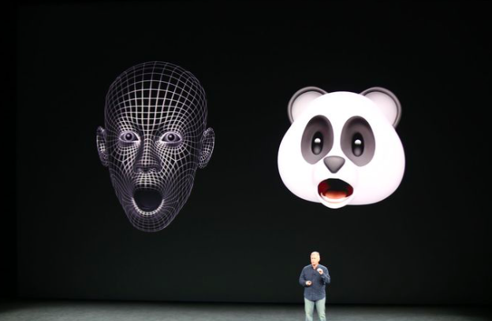

Customer and Investors Sentiments – Apple

Vinod Joshi (11810037) | Meenakshi Naren (11810030)

28-Dec-2018

# Executive Summary

This report provides an analysis of the current customer and investor sentiment about Apple Inc. based on the close observation of their flagship product iPhone. iPhone contributes to approximately 60% of the Apple’s revenue[1], hence the methods of analysis includes a close observation of iPhone sales trend, stock price, service consumption, news, consumer sentiments and compete from the same sector. Results of the analysis show that the recent plunge in Apple’s performance is a reflection of a systematic decline in the sector as opposed to a concrete resemblance of the customer or investor sentiment.

The report finds that Apple Inc. still demonstrates a healthy performance of its flagship product and any inference to its performance would be too early a call.

The report also acknowledges some limitations in the analysis that includes: non-availability of geographic distribution of iPhone sales, lack of age-group based sales distribution, limited information about OnePlus Stock (a compete that is growing rapidly but privately held) and unavailability of App Store’s data for analysis of the paid services consumption.

# Business Problem

iPhones sales in 2018 haven’t shown any increase over the number from the previous year (2017). There hasn’t been a new major product release in the last few years. Apple Inc. stock tumbled more than 30% in the last quarter. Apple Inc. lost its top spot to Microsoft as the company with highest market cap. This could reflect the customer and investor sentiment. As such there are numerous questions that we would like to answer: Is Apple’s customer base diminishing? Is it experiencing a stagnation in growth? Are investors losing faith in the company and its brand? Is there a need for a drastic measure to revive the company?

The problem requires aspect of exploratory data analysis, looking at varied set of data involving companies progress, investor and customer sentiments with influence from the recent events.

# Introduction

Apple Inc. has seen a phenomenal growth in the last decade esp. with the launch of its flagship product called iPhone. While it has been in various businesses, iPhone has been the primary revenue generator for the company. As much as that between 2014- 2016, iPhone contributed to approximately 70% of the Apple’s Revenue. In the 4th quarter of 2018 iPhone still holds 60% of the share of Apple revenue, thus in a way Apple could be called an iPhone company.

In the last six months Apple has been in news for various reasons, including the change in unit sales reporting, potential 10% tariff that could be imposed by the incumbent US government, the US China trade war and above all some skepticism about Apple’s future based on the perceived dearth of innovative products in the last few years.

In our analysis we closely observed iPhone, the flagship product for Apple to build our hypothesis about the consumer and investor sentiment about Apple Inc.

# Questions & Hypothesis

The key questions this analysis would like to answer includes

1. Is Apple Inc. experiencing a stagnation?
2. Is company’s loyal customer base diminishing?
3. Is there shift in the customer sentiments?
4. Has the faith in Apple reduced amongst its investors?

# Hypothesis of our analysis is based on company’s performance for its flagship product iPhone with observation spanning over majorly over last 6-12 months based on the data that is available publicly.

# Methodology & Tools

Our approach to the analysis was exploratory in nature (EDA), since we didn’t have any opinion before getting into the research. In our approach we took the following dimension to analyze the situation and come up with our recommendation

|  |  |
| --- | --- |
| Reports | Read a set of report talking about apple’s shift to not report unit sales, trumps statement, the US China trade war and the current government shutdown. |
| Sales, Income, Units etc. | To measure the performance of the company quantitatively/objectively |
| Product Release | Product releases, pricing, frequency of releases etc. to get insights into the business model |
| Stocks | Looks at the sentiment of the investors as well as the global and US situational impact on the stocks |
| Consumer Sentiments | Sentiments of the consumers across multiple releases to observe if there is a hint for saturation |
| Geography | Quantitative measurement across geographies to identify seasonality |
| Compete | Observe competes in developed and emerging markets to explore variations |
| Technology Sector Trends | How is overall GAMFA stocks trends |
| News | What’s being talked about the company |
| User Interest | Interest about the product in community |
| Service Usage | Usage of the services in iPhone |

Tools used included

|  |  |
| --- | --- |
| Programming | Python |
| Visualization | Tableau |
| Model | Sentiment Analysis with TextBlob |

# Data Collection

Data for our study was sourced from different locations with our primary focus on reliability and completeness. Table below specifies data that was collected, sources that were used and methodology that was applied.

* NOTE: Since Apple principally is an inner source company not all the data is openly available for consumption

|  |  |  |  |
| --- | --- | --- | --- |
| Data Type | Source | Format | Methodology |
| Sales, Net Income | <https://www.statista.com/> | Excel | Download |
| Revenue | <https://www.apple.com/newsroom/pdfs/Q4-18-Data-Summary.pdf> | PDF | OCR |
| Product Releases | <https://en.wikipedia.org/wiki/IPhone> | Web | Scraping |
| GAMFA Stocks | <https://in.finance.yahoo.com/> | Web | Download |
| News | <http://fortune.com/>  <http://techcrunch.com/> | Web | API(s) |
| Consumer Sentiment | <https://twitter.com> | Web | API(s) |
| Product Interest & Compete | <https://trends.google.com/trends/?geo=US> | Web | Charts |
| App Store Usage | <https://www.statista.com/> | Excel | Download |

# Data Understanding

While analyzing the data as part of the EDA we had the following observations

* The pricing data for each version of the iPhone was available as set of ranges. Hence, we had to use the mean to identify the average price per version of the phone. Since we didn’t use the average price in deriving the revenues the average would not impact the revenues.
* Adjusted value of stock used instead of the market close to account for any calculations that happen after the close of the day
* iPhone news was not limited to the product but also has comments around accessories.
* The apple version releases happen in September and March timeframe which causes seasonality in the sales and revenue numbers for quarters
* Different regions have different leader in the mobile phone segment, hence compete in one country (India) may not be the same in another (Brazil).

# Data Cleansing

Majority of the data that was obtained from the Web in download format was clean and complete. However, data pulled from the new channels and twitter feed and content that required cleaning

* Regular Expression to eliminate the context specific noise (#, @ etc., in twitter)
* Special character coming in the news feed
* Eliminating extra spaces in the text
* Removing the numbered hyperlinks from the text e.g. [1]

# Analysis & Result

1. While the quarter on quarter sales of iPhone remains same in 2017 and 2018, we observed a similar pattern in 2015 and 2016 as well. Additionally, this is not an indicator of revenue, which we will observe next.

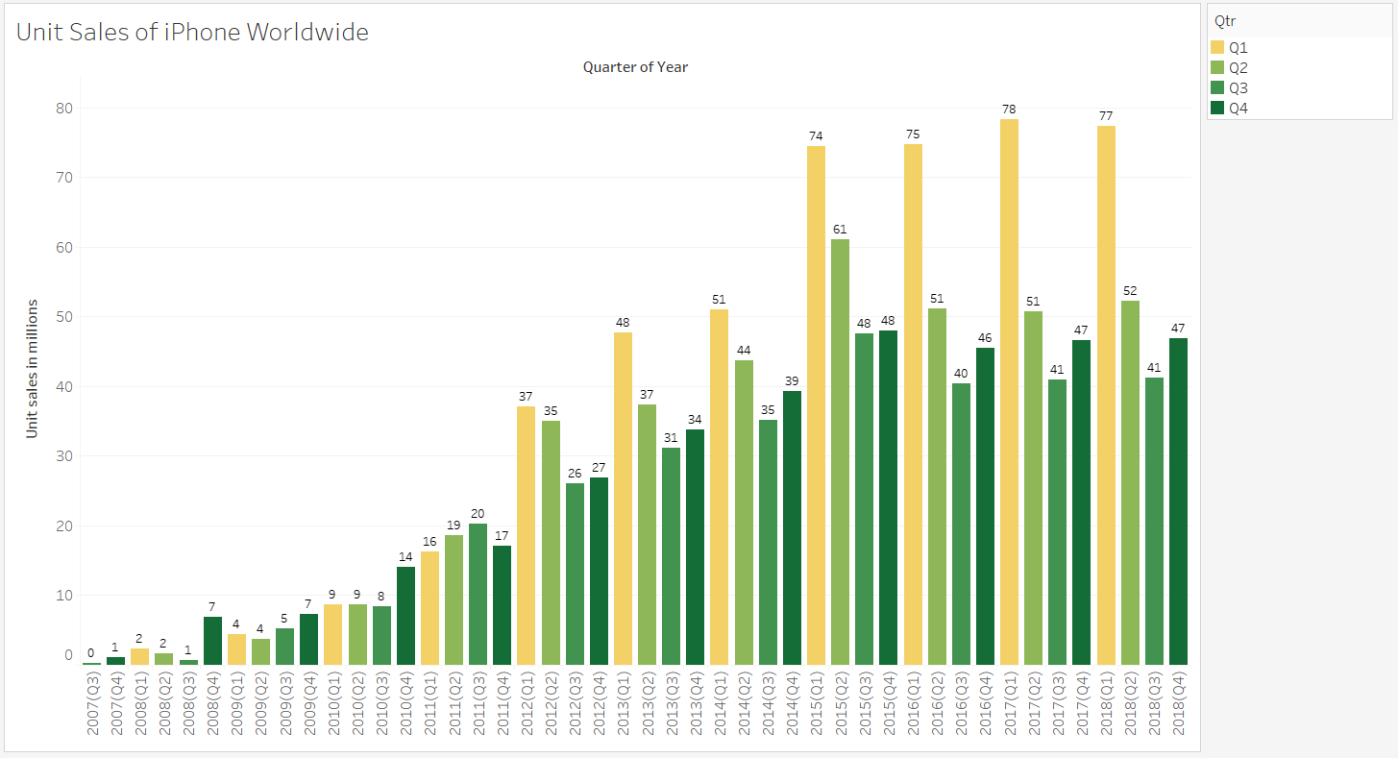

1. Although the unit sales in Q4 of 2017 and 2018 remains stagnant, the revenue generated in Q4 2018 is significantly higher than that of Q4 2017. Selling same number of phones at a higher cost in a period of 12 month is a strong indicator of the value of the brand with the consumers

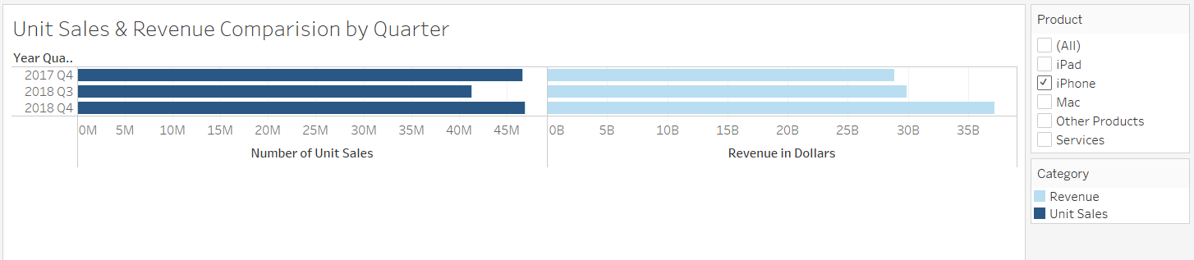

1. In all major regions worldwide, 2018 Q4 iPhone revenue is higher than the previous year’s revenue (2017 Q4 revenue) and previous quarter’s revenue (2018 Q3 revenue)

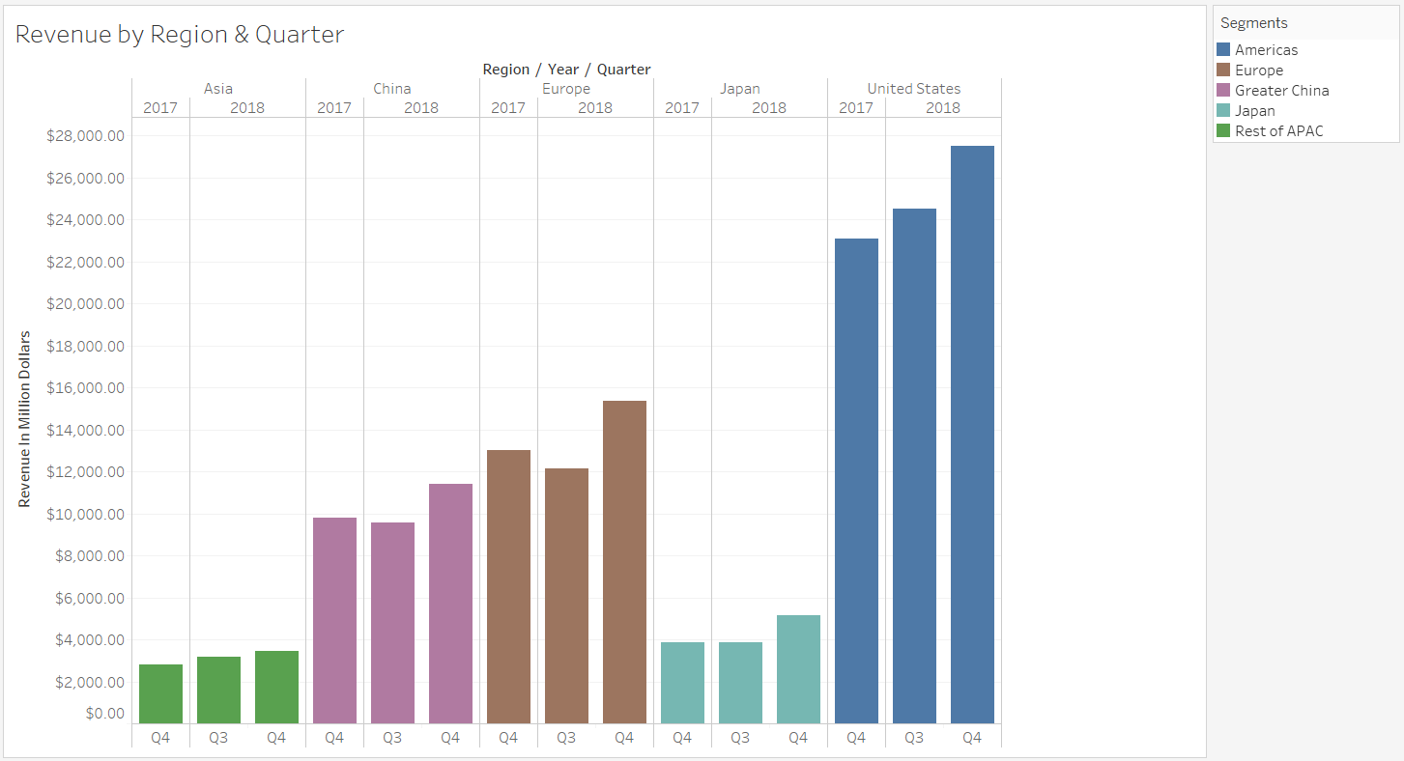

1. Number of iPhone releases and average price per iPhone has gone up in the last 6 years compared to the prior 6. This coupled with the fact that there hasn’t been a drop in the unit sales is another strong indicator of the brand it holds.

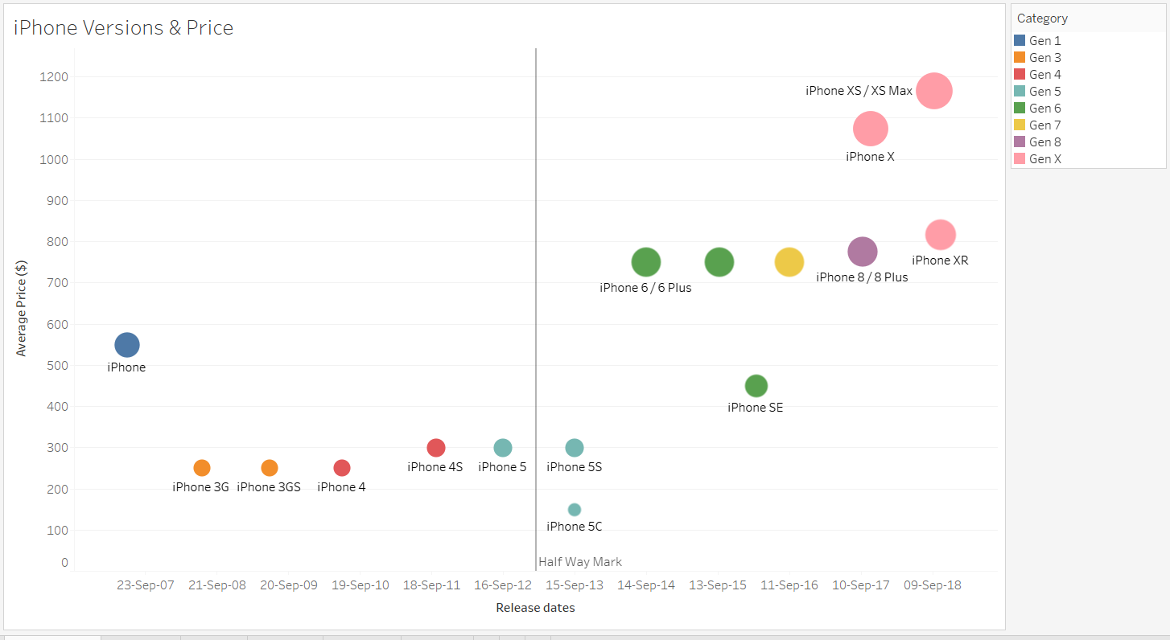

1. Looking at the stock trends for GAMFA (Google, Apple, Microsoft, Facebook and Amazon) in the last couple quarters, the downward trends are analogous reflecting systematic parameters playing a role.

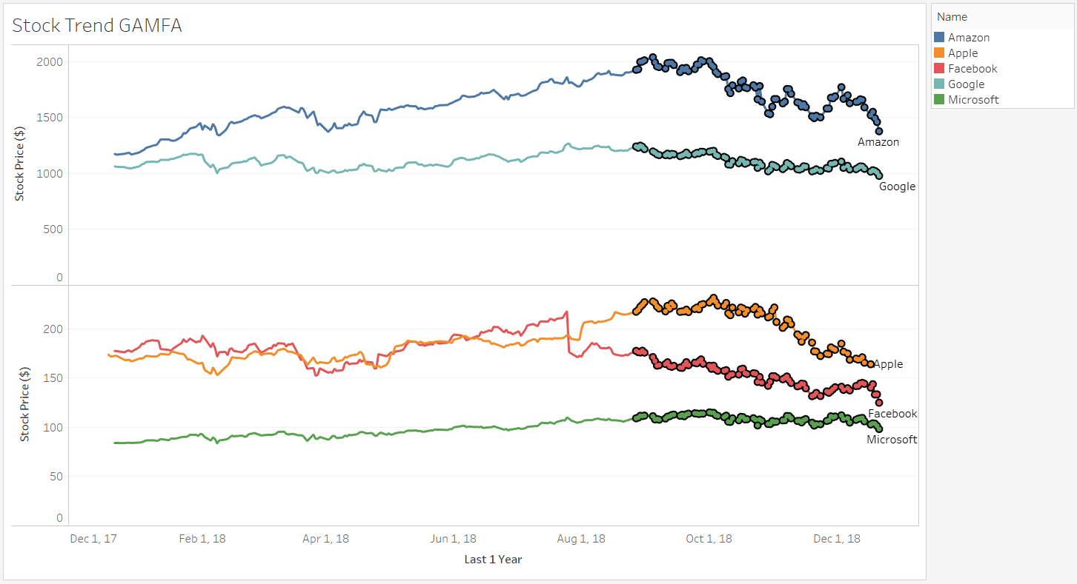

1. Google trends shows that the interest around iPhone and other brands has remained same in the last 12 months with the spike during the iPhone launch. While in India (emerging market) there is a downward trend for Apple and upward trend for Chinese phones, in Brazil (another emerging market) the trend is constant.

|  |  |
| --- | --- |
|  |  |
|  |  |

1. The Net Income of Apple has only increased in the last decade. Since the revenues have increased as well, we believe there is growth in the company, and it isn’t due to due to cost curbs or reduced unit production cost etc.

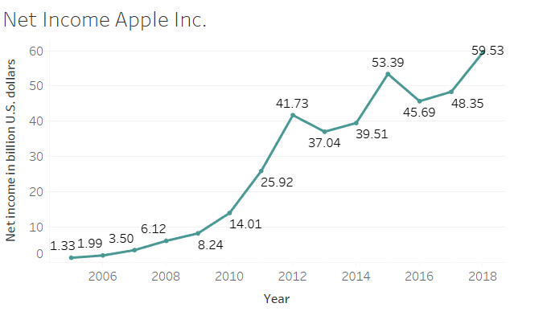

1. Number of active apps on the store is still increasing. There is not enough data to explain the stagnation in the games segment in the last 1 year, however the apps segment is still increasing. Unfortunately we don’t have a view of the paid vs unpaid services to do any further indicative analysis

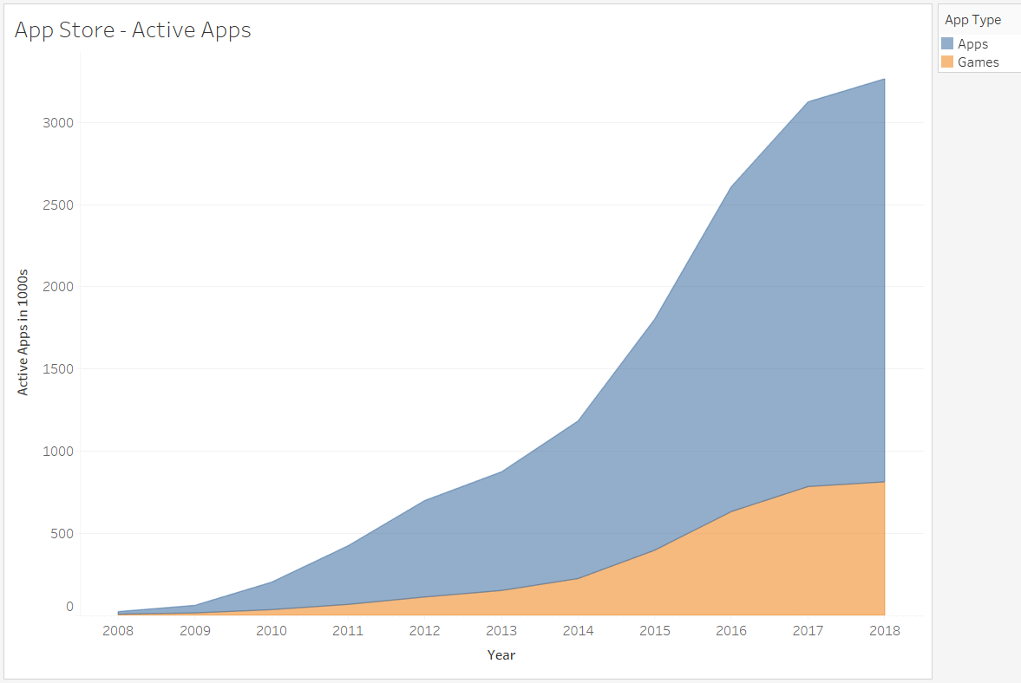

1. Customer Sentiments shows similar patterns for the last 4 years around the September release time frame. The index below the 0 mark indicating negative sentiments has been analogous in the last 4 years including the retweet counts.

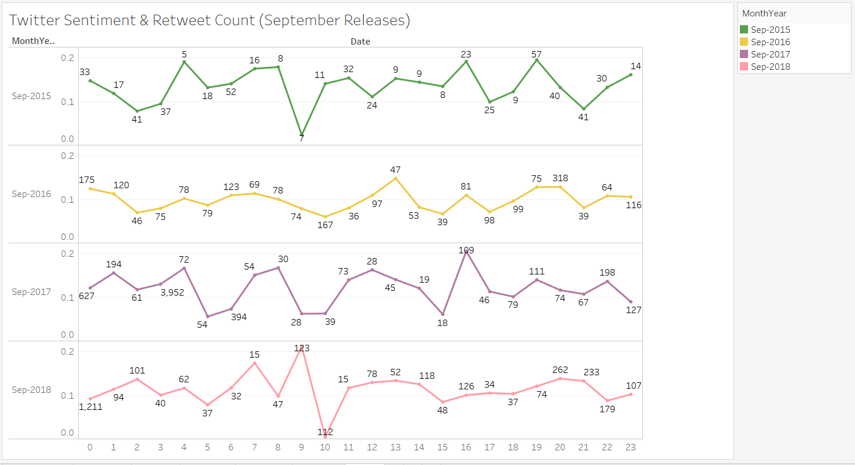

1. The sentiment in the news generally looks positive except for specific instances around US-China trade war and Trump’s statement on 26th Nov about additional 10% tariff.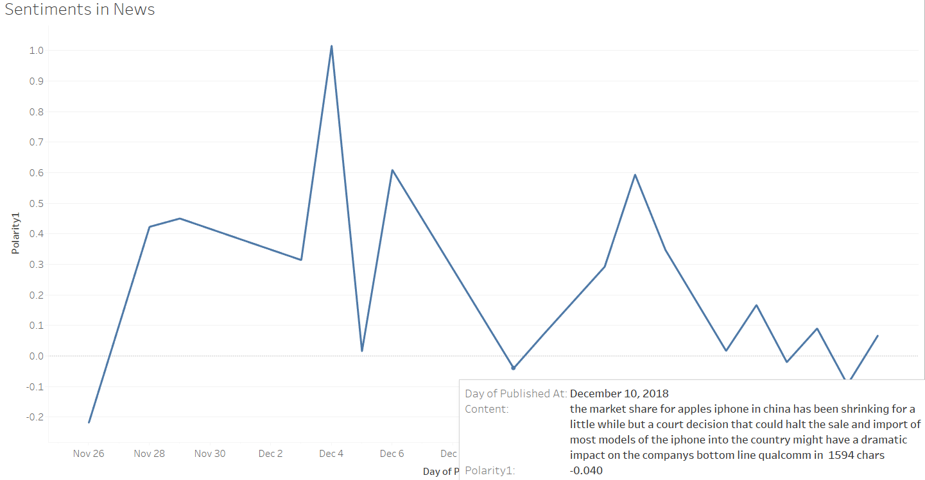

# Conclusion

Year on year increase in apple’s revenue, still holding strong unit sales numbers with more releases per year, Apple is still a strong brand. This coupled with opportunities in the emerging market, strong ecosystem created with multiple product line, unmatched customer centricity and their focus on App Services as a measure of the success opens the possibilities for future.

# Feasibility & Limitations

The study conducted had some limitations due to the unavailability of some of the important information listed below

* No visibility to paid apps: We would like to understand the trend of the usage of the paid services in App Store
* Net Income increase: This could be a factor of cost curbs or production cost reduction which we don’t have a visibility to
* Limited News Data: We only looked at 2 news channels and could only pull the data for last 30 days due to the plan limitations
* As much as we would like to dwell more into the qualitative feedback on twitter, time constraints didn’t permit us to dig deeper e.g. Topic modelling